2D Arrays Test 1

1. Which of the following correctly instantiates a two-dimensional array of strings with dimensions of 3 rows and 5 columns?
2. String[][] arr = new Array[3][5];
3. String[][] arr = new Array[5][3];
4. String[][] arr = new String[3][5];
5. String[][] arr = new String[5][3];
6. Assume a two-dimensional array named mat has been instantiated. Refer to the following code segment.

for (int r = 0; r < /* code1 */ ; r++)

{

for (int c = 0; c < /* code2 */ ; c++)

{  
 System.out.print(mat[r][c] + " ");  
 }

}

Which of the following replaces /* code1 */ and /* code2 */ so that the code above displays the entire contents of mat regardless of its dimensions.

/* code1 */ /* code2 */

1. mat.length mat.length
2. mat.length r
3. mat.length mat[r].length
4. mat.length[r] mat[c].length

**Questions 3-4 refer to the following array declaration.**

Assume a two-dimensional array named mat has been instantiated and has been assigned the following integer values.

|  |  |  |
| --- | --- | --- |
| **1** | **2** | **3** |
| **4** | **5** | **6** |
| **7** | **8** | **9** |

1. What is output by the following code segment?

for (int [] row : mat)  
{  
 for (int n : row)  
 {  
 if(n % 2 == 0)  
 System.out.print(n + " ");  
 }  
}

1. 1 2 3 4 5 6 7 8 9
2. 2 4 6 8
3. 1 3 5 7 9
4. 0 0 0 0 0 0 0 0 0
5. What value is stored in the variable num after the following code has been executed?

int num = 0;  
  
 for (int r = 0; r < 3; r++)  
 {  
 num += mat[r][r];

}

1. 6
2. 12
3. 15
4. 45
5. Consider the following method.

public void mystery()  
 {  
 for (int row = 1; row < mat.length; row++)  
 {  
 for (int col = 0; col < mat[0].length; col++)  
 {  
 if (row != col)  
 mat[row][col] = mat[row – 1][col];  
 }  
 }  
 }

Assume that mat has been instantiated and contains the following values.

|  |  |  |  |  |
| --- | --- | --- | --- | --- |
| 4 | 1 | 3 | 4 | 2 |
| 1 | 8 | 7 | 5 | 3 |
| 7 | 4 | 6 | 9 | 2 |
| 3 | 8 | 1 | 2 | 4 |
| 5 | 6 | 7 | 0 | 3 |

What values does mat contain after a call to mystery?

|  |  |  |  |  |
| --- | --- | --- | --- | --- |
| 4 | 1 | 3 | 4 | 2 |
| 4 | 8 | 3 | 4 | 2 |
| 4 | 8 | 6 | 4 | 2 |
| 4 | 8 | 6 | 2 | 2 |
| 4 | 8 | 6 | 2 | 3 |

|  |  |  |  |  |
| --- | --- | --- | --- | --- |
| 4 | 1 | 3 | 4 | 2 |
| 4 | 1 | 3 | 4 | 2 |
| 4 | 1 | 3 | 4 | 2 |
| 4 | 1 | 3 | 4 | 2 |
| 4 | 1 | 3 | 4 | 2 |

1. B)

|  |  |  |  |  |
| --- | --- | --- | --- | --- |
| 4 | 1 | 3 | 4 | 2 |
| 4 | 1 | 3 | 4 | 2 |
| 1 | 8 | 7 | 5 | 3 |
| 7 | 4 | 6 | 9 | 2 |
| 3 | 8 | 1 | 2 | 4 |

|  |  |  |  |  |
| --- | --- | --- | --- | --- |
| 4 | 4 | 4 | 4 | 4 |
| 1 | 1 | 1 | 1 | 1 |
| 7 | 7 | 7 | 7 | 7 |
| 3 | 3 | 3 | 3 | 3 |
| 5 | 5 | 5 | 5 | 5 |

C) D)

1. Consider the following method.

public void wow()  
 {  
 for (int[] row : mat)

{

for(int col = 0; col < row.length / 2; col++)

{

int temp = row[col];

row[col] = row[row.length - 1 - col];

row[row.length - 1 - col] = temp;

}

}  
 }

Assume that mat has been instantiated and contains the following values.

|  |  |  |  |  |
| --- | --- | --- | --- | --- |
| 1 | 2 | 3 | 4 | 5 |
| 1 | 2 | 3 | 4 | 5 |
| 1 | 2 | 3 | 4 | 5 |
| 1 | 2 | 3 | 4 | 5 |
| 1 | 2 | 3 | 4 | 5 |

What values does mat contain after a call to wow?

|  |  |  |  |  |
| --- | --- | --- | --- | --- |
| 1 | 2 | 3 | 4 | 5 |
| 1 | 2 | 3 | 4 | 5 |
| 1 | 2 | 3 | 4 | 5 |
| 1 | 2 | 3 | 4 | 5 |
| 1 | 2 | 3 | 4 | 5 |

|  |  |  |  |  |
| --- | --- | --- | --- | --- |
| 5 | 4 | 3 | 2 | 1 |
| 5 | 4 | 3 | 2 | 1 |
| 5 | 4 | 3 | 2 | 1 |
| 5 | 4 | 3 | 2 | 1 |
| 5 | 4 | 3 | 2 | 1 |

A) B)

C) D)

|  |  |  |  |  |
| --- | --- | --- | --- | --- |
| 1 | 1 | 1 | 1 | 1 |
| 2 | 2 | 2 | 2 | 2 |
| 3 | 3 | 3 | 3 | 3 |
| 4 | 4 | 4 | 4 | 4 |
| 5 | 5 | 5 | 5 | 5 |

|  |  |  |  |  |
| --- | --- | --- | --- | --- |
| 5 | 5 | 5 | 5 | 5 |
| 4 | 4 | 4 | 4 | 4 |
| 3 | 3 | 3 | 3 | 3 |
| 2 | 2 | 2 | 2 | 2 |
| 1 | 1 | 1 | 1 | 1 |

**Free Response**

A telescope scans a rectangular area of the night sky and collects the data into a 1-dimensional array. Each data value scanned is a number representing the amount of light detected by the telescope. The telescope scans back and forth across the sky (alternating between left to right and right to left) in the pattern indicated below by the arrows. The back-and-forth ordering of the values received from the scan is called *telescope order*.



The telescope records the data in telescope order into a 1-dimensional array of double values. This

1-dimensional array of information received from a single scan will be transferred into a 2-dimensional array, which reconstructs the original view of the rectangular area of the sky. This 2-dimensional array is part of the SkyView class, shown below. In this question you will write a constructor and a method for this class.

public class SkyView

{

/** A rectangular array that holds the data representing a rectangular area of the sky.   
 */

private double[][] view;

/** Constructs a SkyView object from a 1-dimensional array of scan data.

* @param numRows the number of rows represented in the view

* **Precondition**: numRows > 0

* @param numCols the number of columns represented in the view

* **Precondition**: numCols > 0

* @param scanned the scan data received from the telescope, stored in telescope order

* **Precondition**: scanned.length == numRows * numCols

* **Postcondition**: view has been created as a rectangular 2-dimensional array

* with numRows rows and numCols columns and the values in

* scanned have been copied to view and are ordered as

* in the original rectangular area of sky.

*/

public SkyView(int numRows, int numCols, double[] scanned)

{ /* to be implemented in part (a) */ }

/** Returns the average of the values in a rectangular section of view.

* @param startRow the first row index of the section

* @param endRow the last row index of the section

* @param startCol the first column index of the section

* @param endCol the last column index of the section

* **Precondition**: 0 <= startRow <= endRow < view.length

* **Precondition**: 0 <= startCol <= endCol < view[0].length

* @return the average of the values in the specified section of view

*/

public double getAverage(int startRow, int endRow, int startCol, int endCol)  
 { /* to be implemented in part (b) */ }

// There may be instance variables, constructors, and methods that are not shown.

}

1. Write the constructor for the SkyView class. The constructor initializes the view instance variable to a 2-dimensional array with numRows rows and numCols columns. The information from scanned, which is stored in the telescope order, is copied into view to reconstruct the sky view as originally seen by the telescope. The information in scanned must be rearranged as it is stored into view so that the sky view is oriented properly.  
     
   For example, suppose scanned contains values, as shown in the following array.

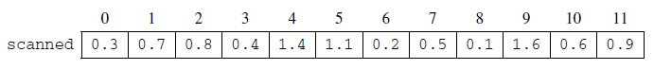

Using the scanned array above, a SkyView object created with new SkyView(4, 3, scanned), would   
 have view initialized with the following values.

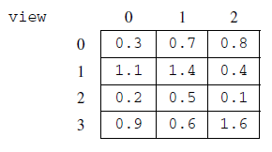

For another example, suppose scanned contains the following values.

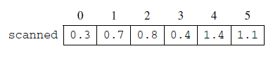

A SkyView object created with new SkyView(3, 2, scanned), would have view initialized with the following values.

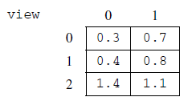

Complete the SkyView constructor below.

/** Constructs a SkyView object from a 1-dimensional array of scan data.

* @param numRows the number of rows represented in the view

* **Precondition**: numRows > 0

* @param numCols the number of columns represented in the view

* **Precondition**: numCols > 0

* @param scanned the scan data received from the telescope, stored in telescope order

* **Precondition**: scanned.length == numRows * numCols

* **Postcondition**: view has been created as a rectangular 2-dimensional array

* with numRows rows and numCols columns and the values in

* scanned have been copied to view and are ordered as

* in the original rectangular area of sky.

*/

public SkyView(int numRows, int numCols, double[] scanned)

1. Write the SkyView method getAverage, which returns the average of the elements of the section of view with row indexes from startRow through endRow, inclusive, and column indexes from startCol through endCol, inclusive.

For example, if nightSky is a SkyView object where view contains the values shown below, the call nightSky.getAverage(1, 2, 0, 1) should return 0.8. (The average is (1.1 + 1.4 + 0.2 + 0.5) / 4, which equals 0.8). The section being averaged is indicated by the dark outline in the table below.

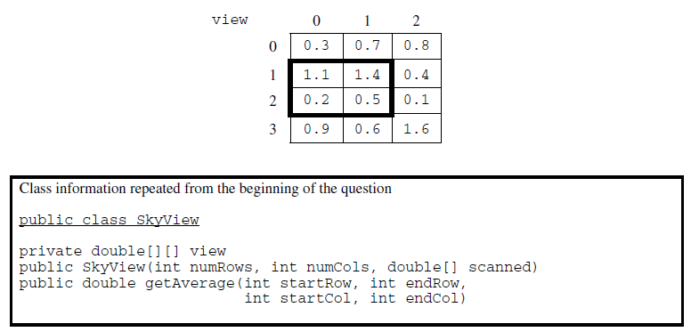

Complete method getAverage below.

/** Returns the average of the values in a rectangular section of view.

* @param startRow the first row index of the section

* @param endRow the last row index of the section

* @param startCol the first column index of the section

* @param endCol the last column index of the section

* **Precondition**: 0 <= startRow <= endRow < view.length

* **Precondition**: 0 <= startCol <= endCol < view[0].length

* @return the average of the values in the specified section of view

*/

public double getAverage(int startRow, int endRow, int startCol, int endCol)